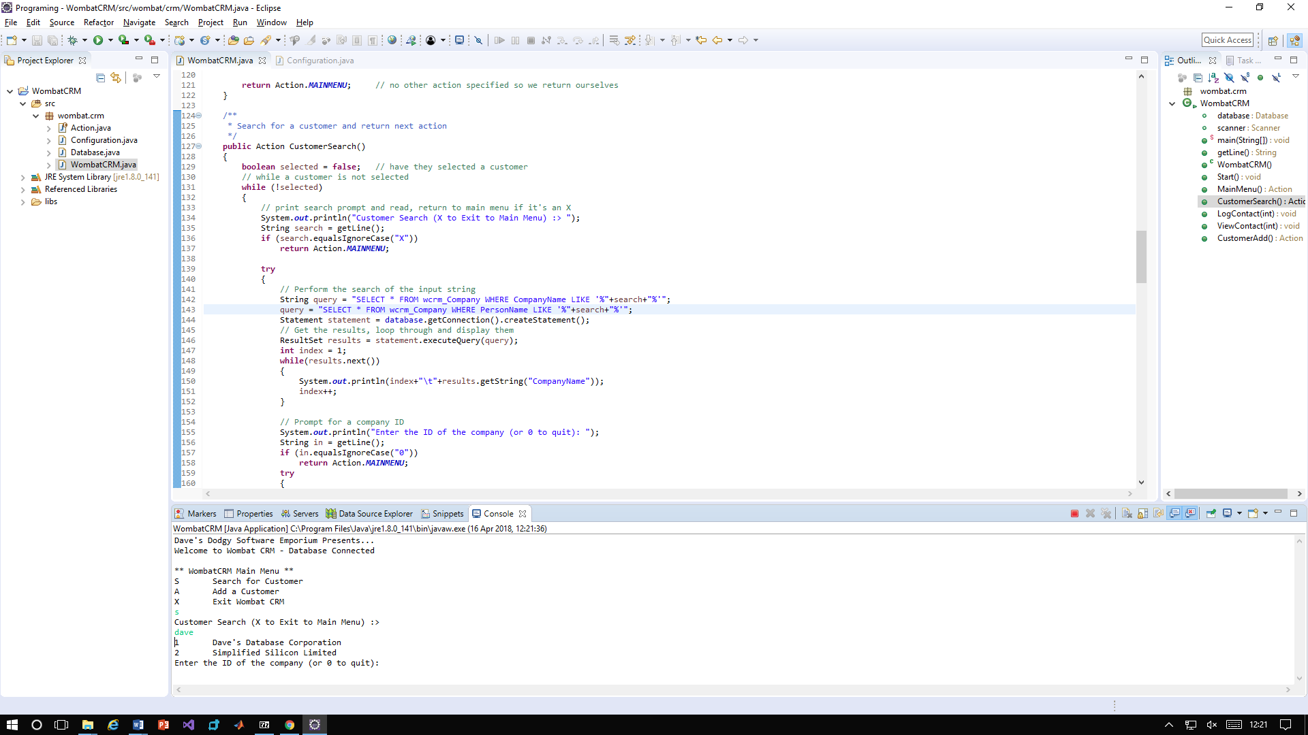

1. A search is performed against a company both the CompanyName and the PersonName are checked for the search term and both are displayed.

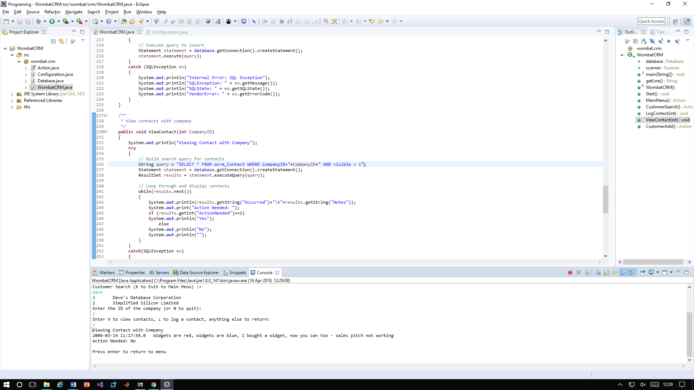

1. When a list of contacts against a company is shown on the screen those that have the visible flag unset (set to 0) are not displayed.

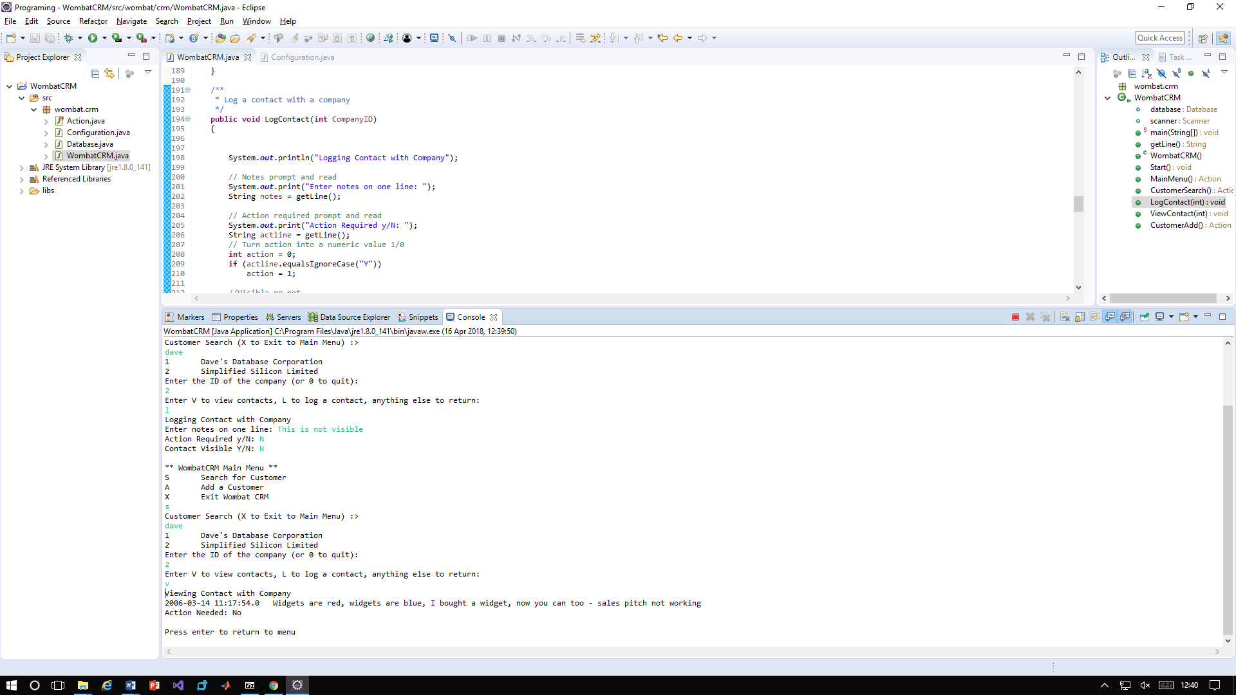

1. 3. When a contact is logged the user is able to set if it should be visible or not.